Assignment 15
Using Subqueries with DML Commands.

Question 1 = Assume there is a table called Multicust,with all of the same column definitions as Salespeople. Write a command that inserts all salespeople with more than one customer into the table.
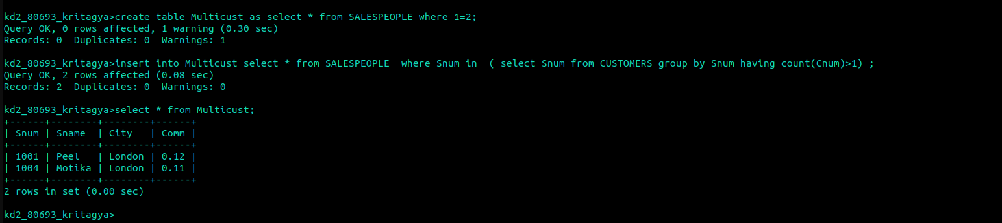

Main query

Question 2 = Write a command that deletes all customers with no current orders.

Question 3. Write a command that increases by twenty percent the commissions of all salespeople with total orders above Rs 3000.

